Created Jenkins Master and slave installed Git, Maven, tomcat, Java and Jenkins in JM and Java and tomcat on Slave machine
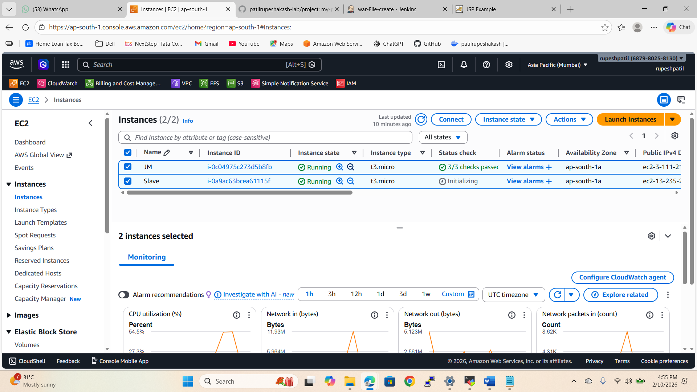

Created the IAM role for full access to the S3 bucket for the configuration purpose
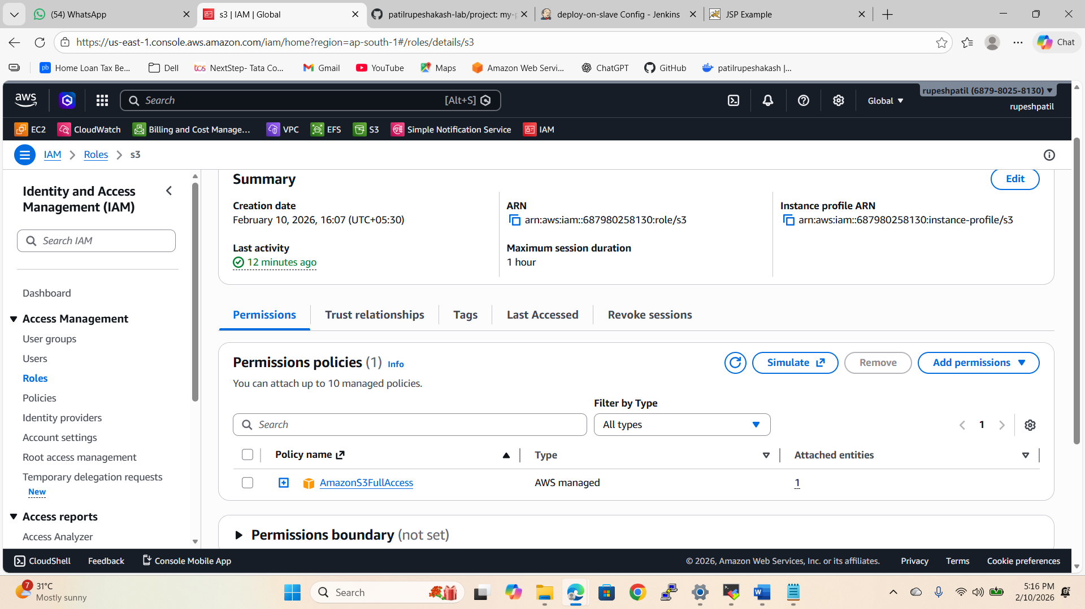

Created 3 Jobs as on one job entire pipeline is not working because of the small machine
- war-File-create- Created the WAR file by creating small pipeline and using Maven- running on Build-in
- s3bucket-create-and-copy-WAR- using CLI commend, created s3 bucket and copied the WAR file in it- running on Build-in
- deploy-on-slave- using CLI command copied the WAR file from s3 bucket to the webapp folder in slave machine- running on qa(slace)
- Connected the 1st 2nd and 3rd job using post build actions. When 1st build run it will trigger 2nd build and 2nd build will trigger 3rd build.

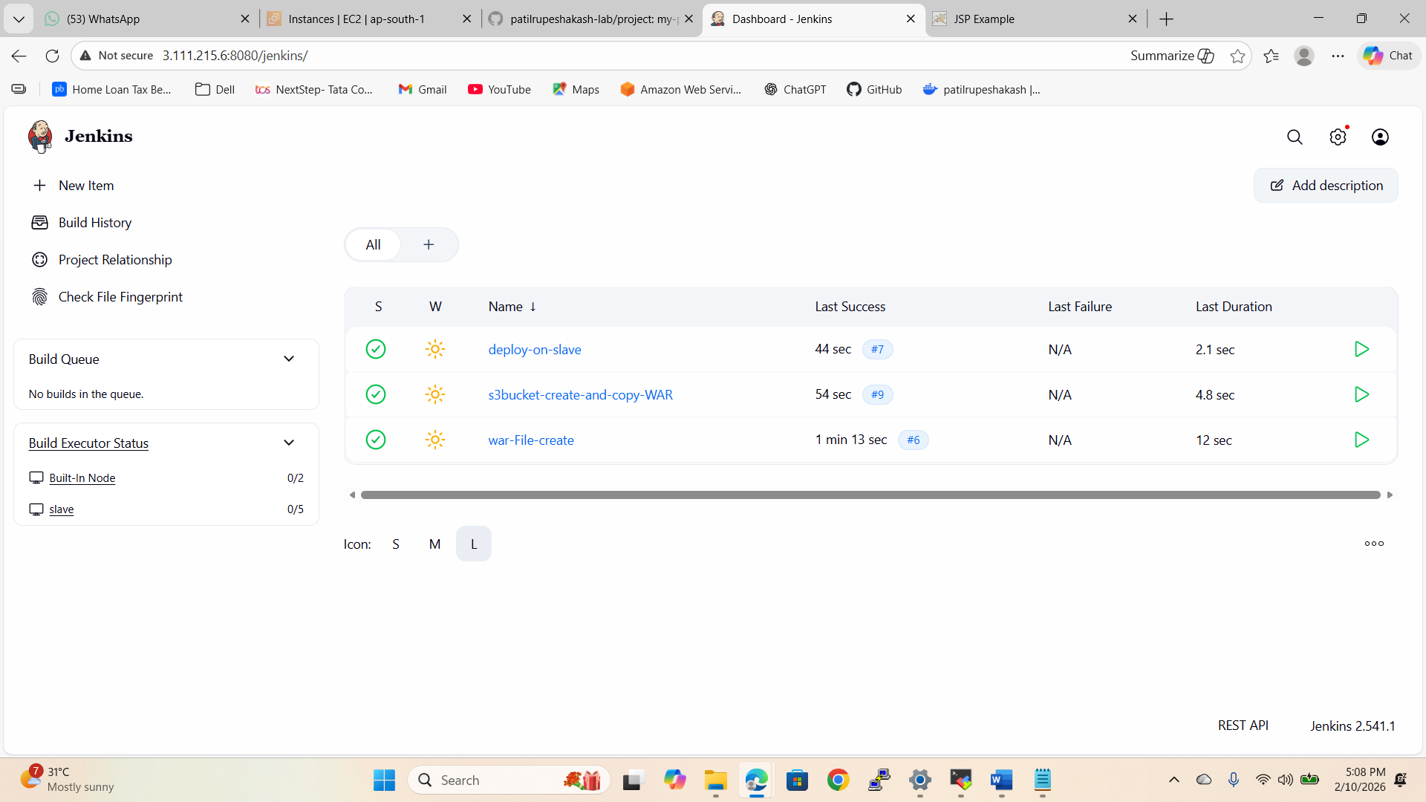

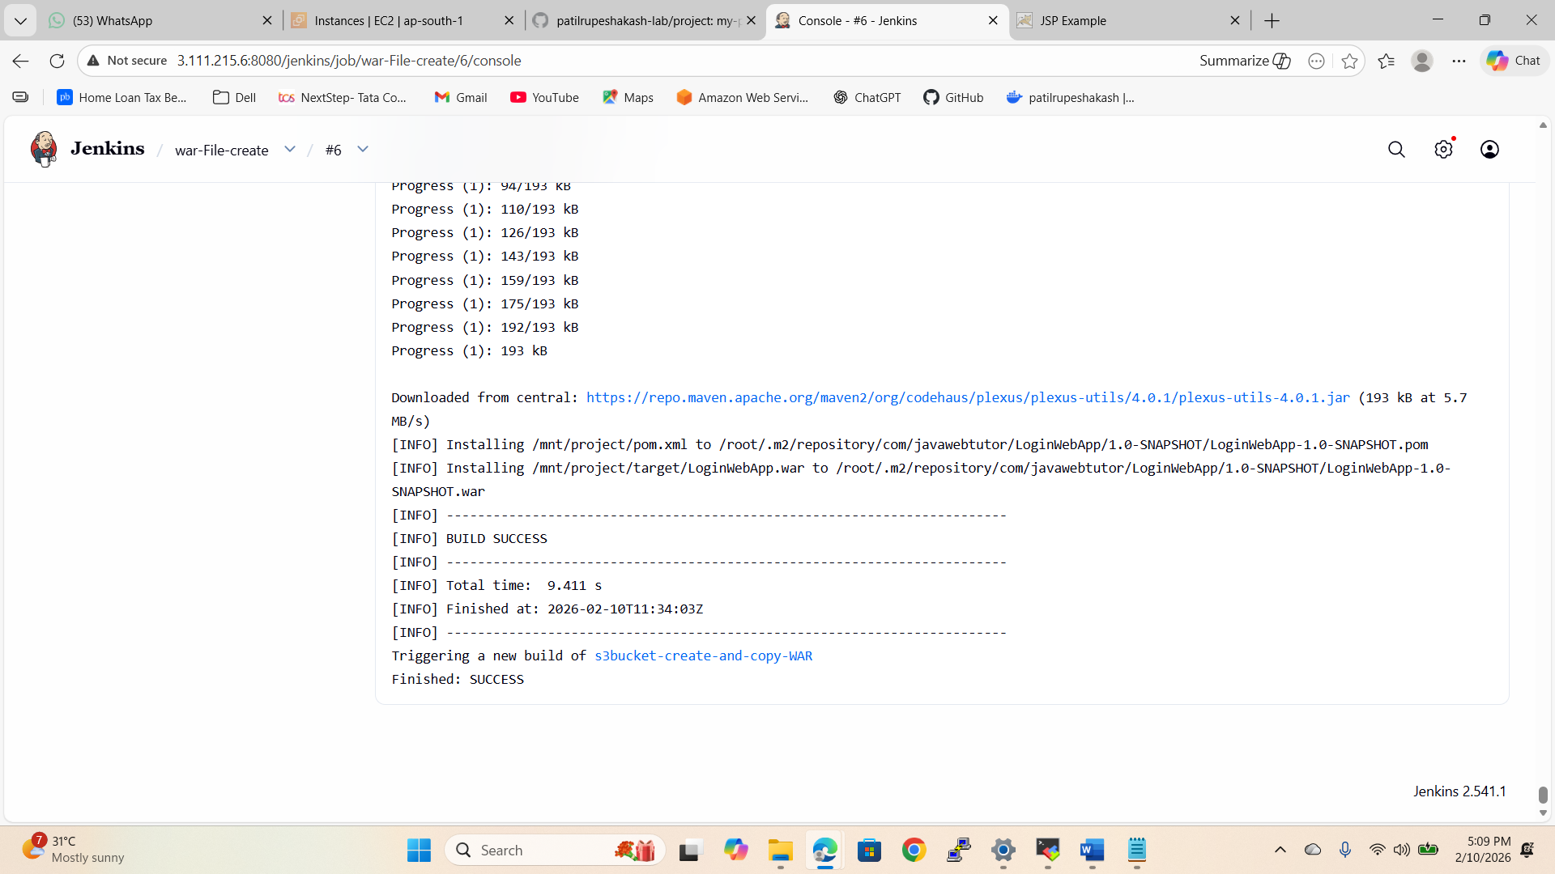
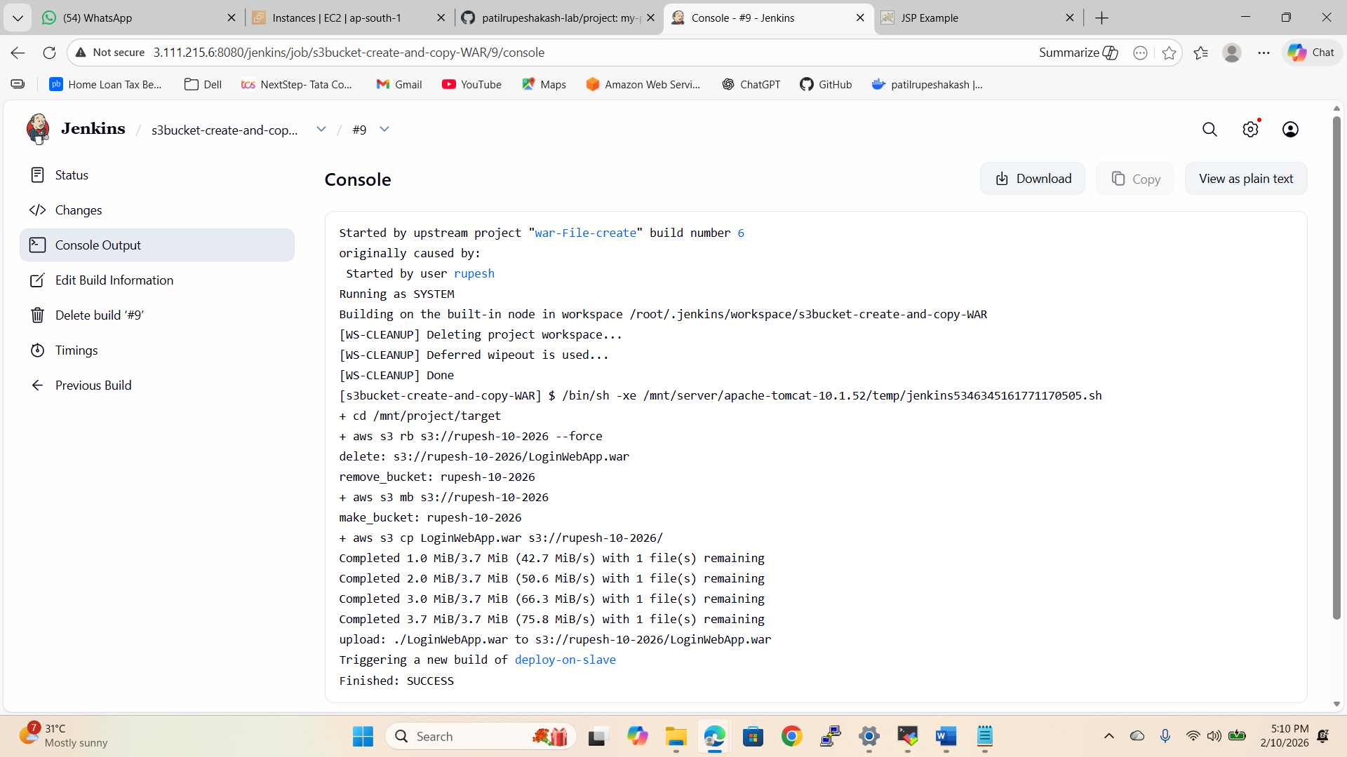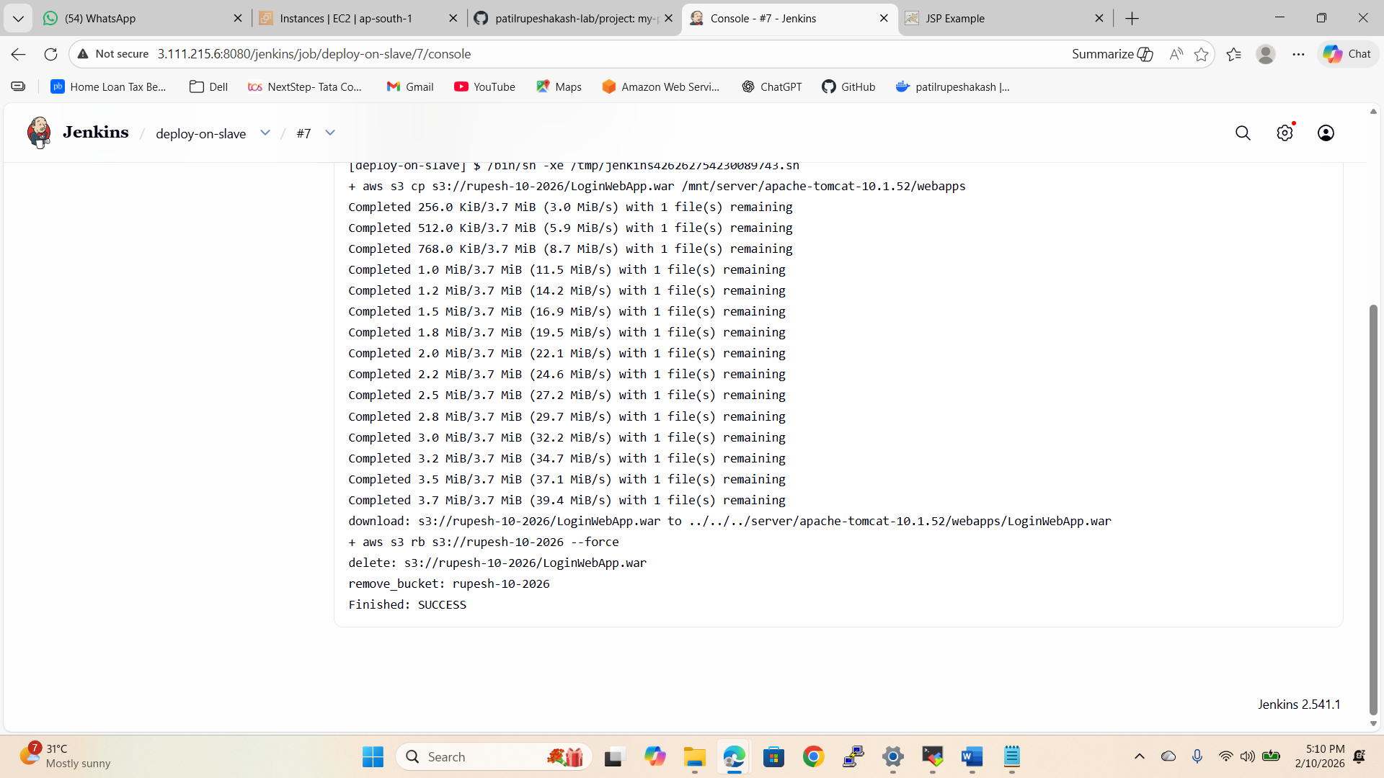

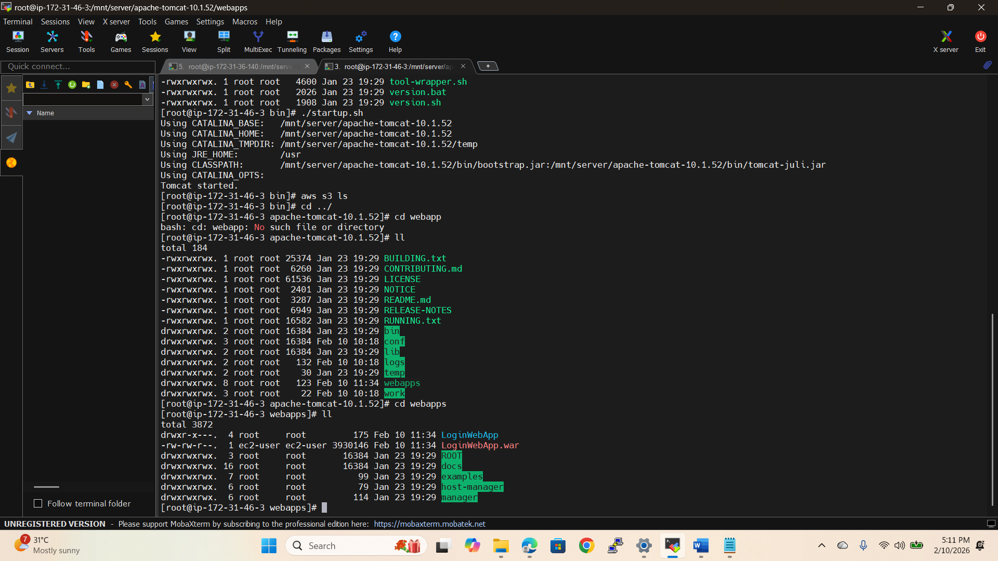

Website running
